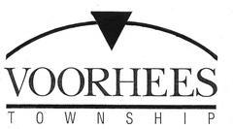

JOB OPPORTUNITY

TITLE: Tax Assessor Trainee—Full Time

DEPARTMENT: Tax Assessor

RESPONSIBILITIES: Under close supervision in a trainee program, performs productive work while receiving formal and/or on-the-job training in accumulating data that will be used in establishing a system of valuations for real property; does related work as required. An expanded outline of duties for this position can be found here:

http://info.csc.state.nj.us/jobspec/00300.htm

Submit job application and resume by November 26th, 2017 to:

Voorhees Township
Human Resources with Trainee in the subject line to:

applicant@voorheesnj.com

