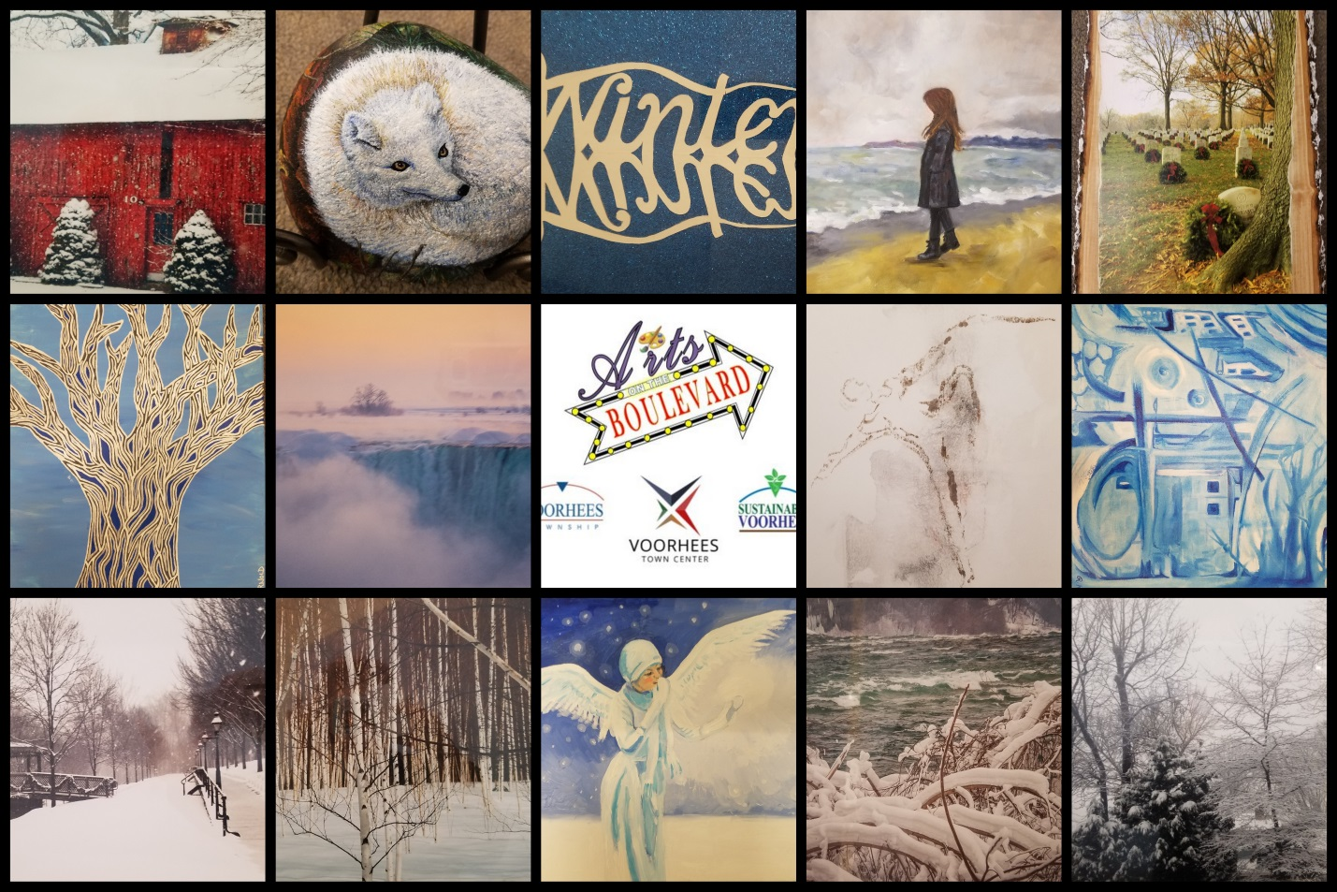
Voorhees Arts Council Arts on the Boulevard
Winter Exhibit
Who wants to stand in the cold to enjoy art?
Visit the artwork of 14 local artists in the warmth of the
Voorhees Town Center Mall, just down the boulevard.
You will find great images at the back of the food court,
in the windows of the old Joyce Leslie space.
This winter themed exhibit will be up until the end of March.
For more information on this program visit
www.sustainablevoorhees.org
