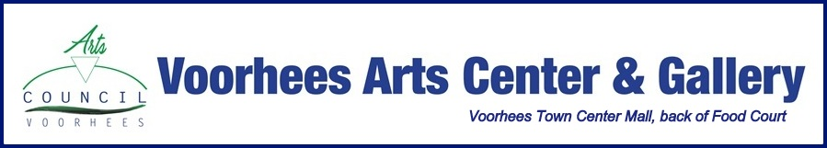
Create Your Own Art Party!
You provide the friends, we provide the place, artist and materials (if needed).
You pick date, 7pm-9pm. Minimum 5 friends. BYOB. $25 each.
Holiday Special 25% off: $100 gift certificate for group of 5 redeemable in 2019.
Great gift idea for the person who has everything.
For details contact marianne@marianneleone.com

- Wine Glass Painting  - Photography Book Creation  - Belly Dancing Private Class  - Alcohol Ink Creation on Paper/Scarf  - Bead & Wiring- Tree of Life and more  - Blackboard Creation and Decorating  - Zentangle Creation  - Paint Your Own Pottery | - Paint on Canvas  - Holiday Votive Set Creation  - Bath Salts, Artisan Soap & Candle Making  - Mask Paper Mache  - Monotype Printing  - Make a Fairy Garden  - Holiday Nature Basket  - Memory Wire Jewelry Making

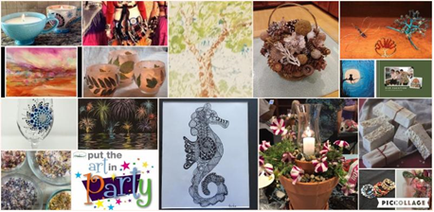
We Thank Our Sponsors!
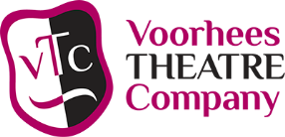 | 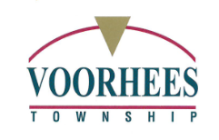 | 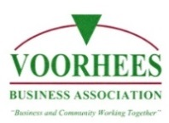 | 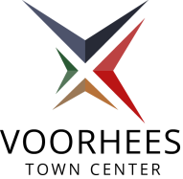 | 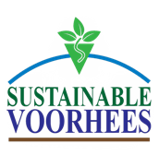 | 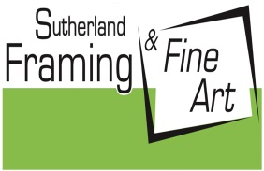
 |  | 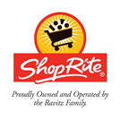 | 