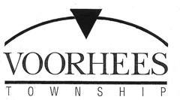

JOB OPPORTUNITY

TITLE: Clerk 1 – Part-Time

DEPARTMENT: Police Records

RESPONSIBILITIES: Perform moderately complex and non-routine clerical work involving the processing and filing of records.

Must be knowledgeable in Microsoft Office 365 Programs.

Must work effectively with members of the public as well as associates.

Must successfully complete background check.

Submit resume and letter of interest to
applicant@voorheesnj.com

or

Complete a job application that can be found at
www.voorheesnj.com

or in person at
2400 Voorhees Town Center
Voorhees NJ 08043

