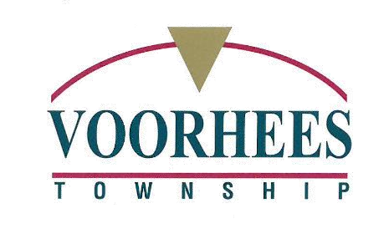

CALL
911

FOR EMERGENCIES ONLY

Atlantic City Electric: 1-800-833-7476 / www.atlanticcityelectric.com/home/

PSE&G: 1-800-436-7734 / www.pseg.com/home/customer_service/outage_info/index.jsp

New Jersey American Water: 1-800-272-1325 / www.amwater.com

South Jersey Gas: 1-800-582-7060 / www.southjerseygas.com

Verizon: 1-800-837-4966 / www.verizon.com

Xfinity / Comcast: 1-800-934-6489 / www.xfinity.com

Camden County Public Works: 856-566-2980 (County Roads)
Voorhees Township Fire Department: 856-783-6630 (Non-Emergency)
Voorhees Township Police Department: 856-428-5400 (Non-Emergency)
Voorhees Township Sewer Department: 856-428-6925
Voorhees Township Public Works: 856-428-5499
NJ Department of Transportation: 856-486-6631 (State Roads)
NJ 211: Dial 2-1-1 / www.nj211.org – 24/7 help with assistance and resource services
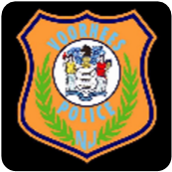
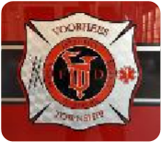

In case of power outage please report directly to the appropriate utility provider. Always keep a copy of your bill when contacting utility provider.
Treat all downed wires as “hot” and never touch or move a downed wire.
Never drive through flooded roads or barriers

