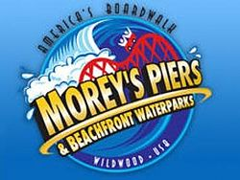

VOORHEES TOWNSHIP HAS PARTNERED AGAIN WITH MOREY’S PIERS IN WILDWOOD TO SELL DISCOUNTED PASSES TO THEIR AMUSEMENT PIERS. PRICES ARE LISTED BELOW. TICKETS CAN BE PURCHASED IN PERSON ONLY AT THE TOWNSHIP CLERK’S OFFICE, 2400 VOORHEES TOWN CENTER, VOORHEES, NJ 08043. ACCEPTED PAYMENT IS CASH OR CHECK ONLY.

FLEXIBLE RIDE & WATER PARK COMBINATION $80.00

SAME DAY RIDE & WATER PARK – VALID ONE DAY ONLY $71.92

AMUSEMENT ONLY $45.14

WATER PARK TICKET $44.25

