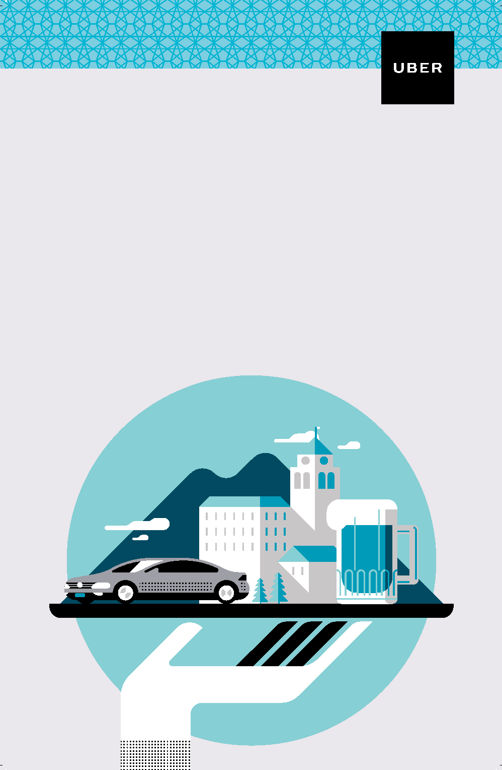



Voorhees Citizens Events Foundation

(Up to Max $15.Tips not included)

2 rides per month

You must have an UBER account

Select the **VOORHEES** option in the app

Scan the QR code to receive a voucher.

You must have an UBER account

Uber and Voorhees Township are working together to reduce alcohol-related car incidents. Rides requested between 9:00pm–2:00am from this location to a

Voorhees residence are free. Scan the above QR code

to receive a voucher.

Free ride home.

Voorhees Saves Lives