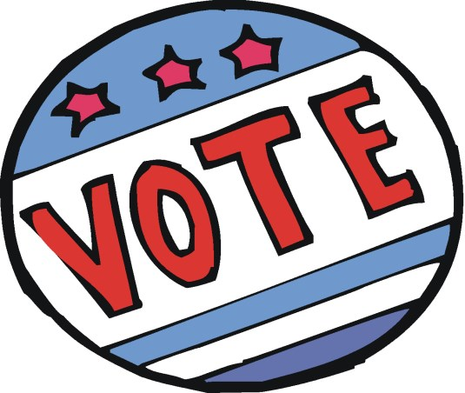

POLLING PLACE LOCATIONS - 2020
Several have been changed

Kirkwood Fire Hall – Districts 2 & 18
Town Hall Courtroom – Districts 5, & 12
Macy’s Court – Districts 1, 4 & 7
Food Court – Districts 17 & 19
Lion’s Lake – Districts 3, 10, 13 & 15
School Admin Building – Districts 6, 9, 10 &14
Hampton Inn - Districts 11 & 16

ANY QUESTIONS REGARDING POLLING PLACES
PLEASE CALL THE TOWNSHIP CLERK AT (856)429-7757

