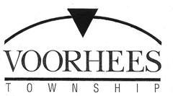

JOB OPPORTUNITY

DATE: December 15, 2020

TITLE: Clerk – Part Time

DEPARTMENT: Department of Construction

RESPONSIBILITIES:

  - Reviews applications for construction permits to ensure all necessary information and documents are included and requests additional information as instructed or directed by the appropriate Sub-Code or Construction Official

  - Schedules inspections proceedings; may process requests for scheduling changes.

  - Must work effectively with members of the public as well as associates.

  - Must be knowledgeable in Microsoft Office and have ability to compose correspondence and create/maintain spreadsheets.

  - Must have strong writing skills.

Submit job application or resume to:

Voorhees Township
Human Resources
2400 Voorhees Town Center
Voorhees, NJ 08043

Fax (856) 429-3766 applicant@voorheesnj.com

