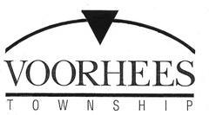
JOB OPPORTUNITY

DATE: September 28, 2021

TITLE: Part-Time Building and Plumbing Inspectors

DEPARTMENT: Construction

RESPONSIBILITIES:

- ICS Building Inspector License minimum requirement.

- HHS Plumbing License minimum requirement.

- Responsible for administering and enforcing building and related codes.

- Inspects construction jobs, checks quality and amount of work completed, and resolves construction problems.

- Requires thorough knowledge of the State of N.J. Uniform Construction code and related technical subcodes and standards.

- Valid NJ driver’s license required.

- Exceptional customer-service skills and computer proficiency required.

- Applicants with additional licenses are encouraged to apply.

Submit job application or resume to:

Voorhees Township
Human Resources
2400 Voorhees Town Center
Voorhees, NJ 08043

Fax (856) 429-3766
or
applicant@voorheesnj.com

