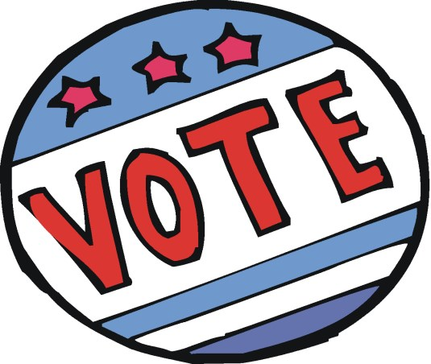

POLLING PLACE LOCATIONS - 2021
Several locations have changed

Ashland Church District 1
Kirkwood Fire Hall District 2
Town Hall Courtroom Districts 5 & 12
Macy’s Court Districts 4, 7 & 18
Kresson Fire Hall District 8
Food Court Districts 17 & 19
Lion’s Lake Districts 3, 10, 13 & 15
School Admin Building Districts 6, 9 & 14
Hampton Inn - Districts 11 & 16

ANY QUESTIONS REGARDING POLLING PLACES
PLEASE CALL THE TOWNSHIP CLERK AT (856)429-7757

