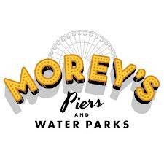

Voorhees Township is once again partnering with Morey’s Piers to offer discounted tickets for their amusement piers located on the Boardwalk in Wildwood, NJ.

Tickets may be obtained in person from the office of the Voorhees Township Clerk (856) 429-7757 and are payable by CASH ONLY. Tickets are available to residents and non-residents.

Office Hours until Memorial Day weekend
Monday-Friday, 8:30 am to 4:30 pm

then

Tuesday, May 28th – Friday, August 30th
Monday through Thursday, 8:00 am to 5:30 pm

The tickets are good any day and do not expire.

Prices are as follows:

Splash & Ride Combination Pass - $97.00

Combo tickets include ALL DAY admission to both the Morey's Amusement Piers, and the "Raging Waters” or “Ocean Oasis” beachfront water parks. (2 days on one ticket) Tickets may be used on the same day or two different days, (one day for each activity).
(Does not include Go Karts boat tag, skyscraper, sky coaster or Golf)

Water Park Pass - $55.00

Includes all day admission to both "Raging Waters” and “Ocean Oasis” beachfront water parks (Does not include amusement rides)

